DATA SCIENCE AND VISUALIZATION
WEEK 4 REPORT
EDA DEEP DIVE
Univariate and Bivariate Analysis • Visualizing Distributions

TEAM 12
Nivetha S — 25BAD074
Pooja T — 25BAD077
Puvi Priya M — 25BAD084
Vaishnavi D — 25BAD126
Project: Autoimmune Disorder Data Analysis and Visualization
Week 4 Status: Completed
GitHub Repository: https://github.com/nivetha486/24ADI204_DSV_Team12

1. INTRODUCTION
Week 4 continues the exploratory data analysis work after the Week 3 Cleaning Sprint. The main focus is an EDA Deep Dive using univariate and bivariate analysis. The analysis examines individual variables to understand their distributions and then studies relationships between pairs of variables using appropriate statistical and visual techniques.
The Week 4 notebooks use the cleaned autoimmune-disorder dataset and focus on clinical, hematological, symptom, demographic and diagnosis-related variables. Visualizations are used to make patterns, spread, concentration, and differences easier to interpret.

2. OBJECTIVES
• Perform univariate analysis on numerical and categorical variables.
• Visualize numerical distributions using histograms, box plots, violin plots, ECDF plots and Q-Q plots.
• Visualize categorical distributions using bar charts and pie charts.
• Measure distribution shape using skewness for selected numerical variables.
• Perform bivariate analysis between numerical, categorical and mixed variable types.
• Compare age, neutrophils and hemoglobin distributions across demographic or diagnosis groups.
• Examine relationships among inflammatory and hematological measurements.
• Use correlation and other visual summaries to support exploratory interpretation.

3. DATASET DESCRIPTION
The Week 4 bivariate-analysis notebook loads the cleaned autoimmune-disorder dataset and reports 12,500 entries and 76 columns. The dataset contains numerical and categorical variables, including Age, Gender, Diagnosis, CBC measurements, inflammatory markers, symptoms and autoantibody indicators.
Dataset Information | Week 4 Details
Dataset | Cleaned Comprehensive Autoimmune Disorder Dataset
Rows | 12,500
Columns | 76
Domain | Healthcare / Clinical Data
Analysis stage | Exploratory Data Analysis
Main areas | Distributions, comparisons, relationships and correlations

4. TOOLS AND TECHNOLOGIES USED
Tool / Library | Purpose
Python | Programming and exploratory analysis
Jupyter Notebook / Google Colab | Running and documenting analysis
Pandas | Data loading, grouping and tabulation
NumPy | Numerical calculations
Matplotlib | Plotting and visualization
Seaborn | Statistical visualization
SciPy | Q-Q plot and statistical utilities

5. UNIVARIATE ANALYSIS
Univariate analysis studies one variable at a time. In Week 4, numerical variables such as Age, Hemoglobin, RBC_Count, Hematocrit, MCV, ESR and CRP were examined with multiple distribution plots. Categorical and binary variables such as Gender, Low-grade fever, Fatigue or chronic tiredness and Joint pain were also summarized.

5.1 Histogram and KDE – Age and Hemoglobin
Histograms show the frequency of observations across value ranges, while the KDE curve provides a smoothed view of the distribution. The Age histogram shows observations spread across the adult age range represented in the dataset. The Hemoglobin histogram shows a visibly stronger concentration around the middle of its observed range, with fewer observations toward the higher end.
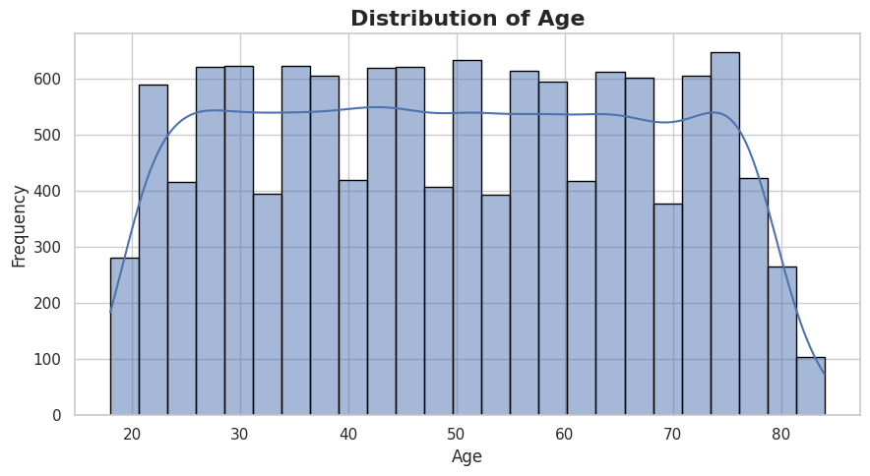
Figure 1. Distribution of Age
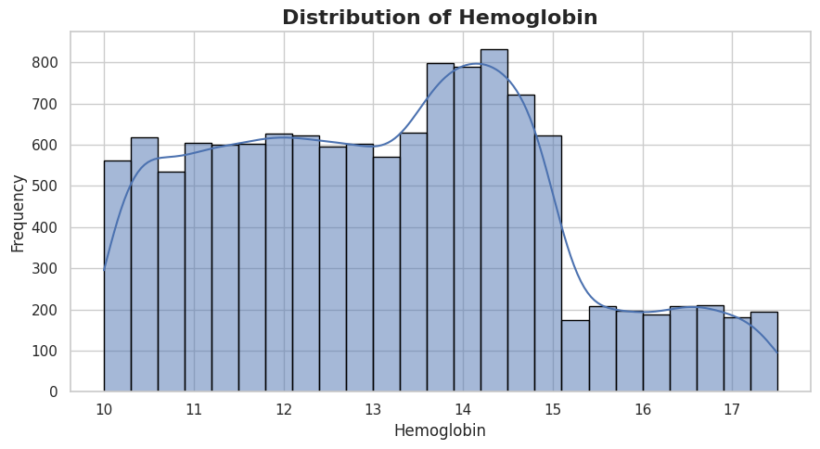
Figure 2. Distribution of Hemoglobin

5.2 Box Plot – RBC Count and Hemoglobin
Box plots summarize the median, interquartile range and potential extreme observations. The Week 4 notebook applies box plots to RBC_Count and Hemoglobin so that their central tendency and spread can be compared without relying only on the histogram.
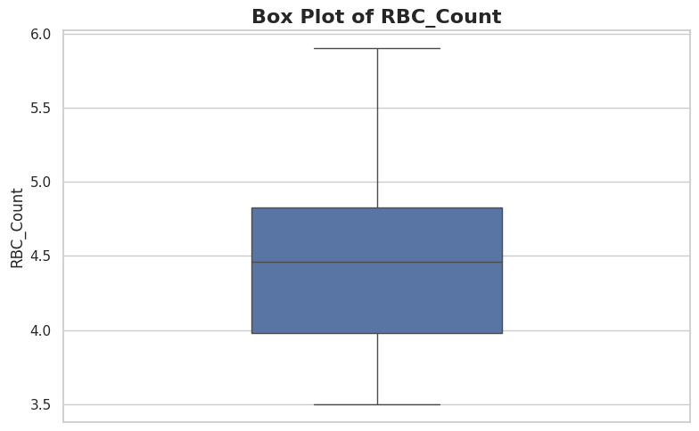
Figure 3A. Box plot for RBC_Count
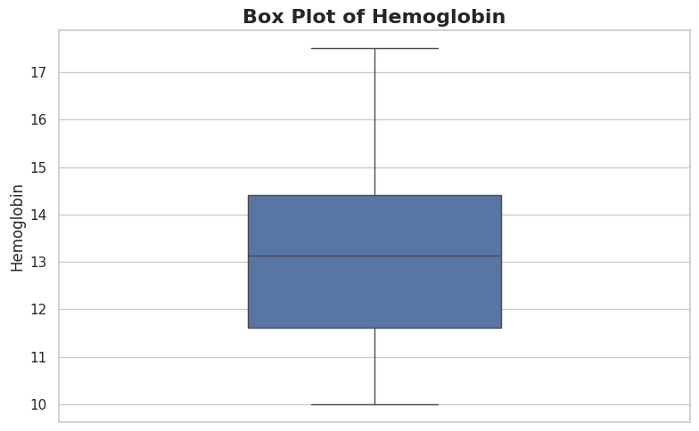
Figure 3B. Box plot for Hemoglobin

5.3 Violin Plot – Hematocrit and MCV
Violin plots combine distribution shape with summary information. The notebook uses the inner quartiles to show where observations are concentrated. This is useful for seeing the overall shape of Hematocrit and MCV rather than only their quartiles.
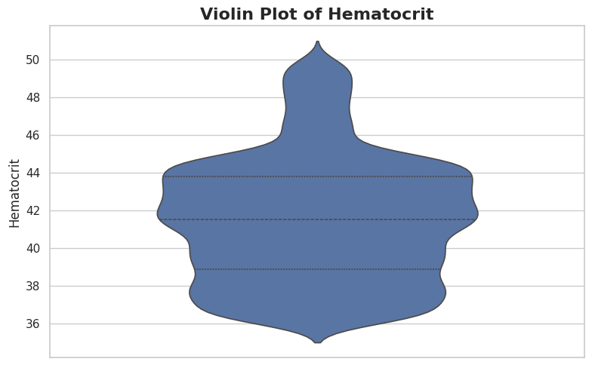
Figure 4A. Violin plot for Hematocrit
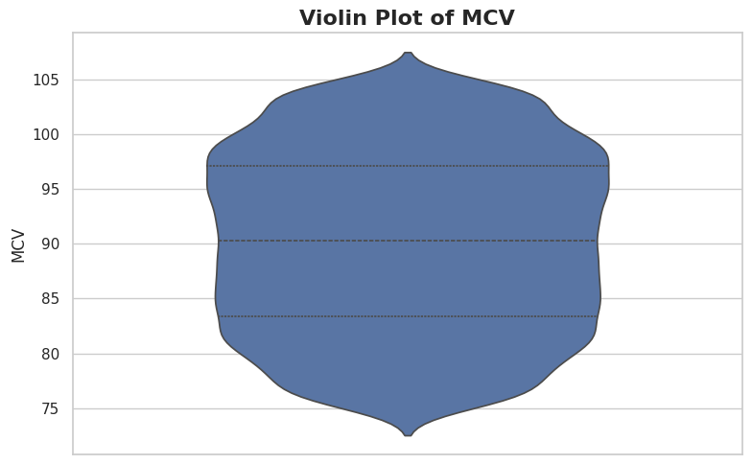
Figure 4B. Violin plot for MCV

5.4 ECDF – ESR and CRP
Empirical cumulative distribution functions (ECDFs) show the proportion of observations at or below each value. They provide a direct view of how observations accumulate across ESR and CRP and are useful for comparing the spread of inflammatory measurements.
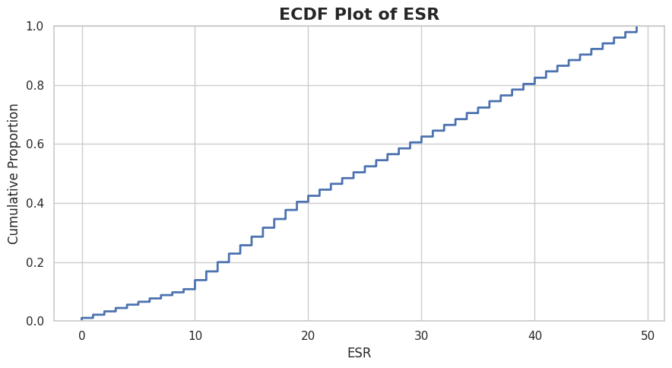
Figure 5A. ECDF for ESR
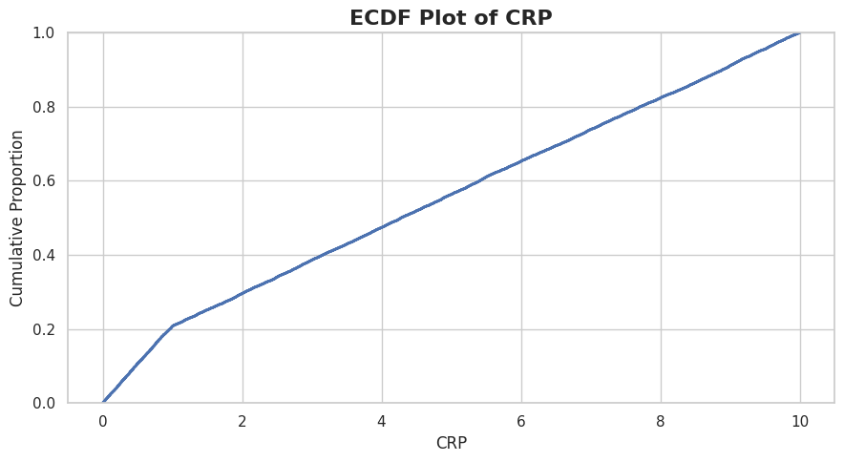
Figure 5B. ECDF for CRP

5.5 Q-Q Plot and Skewness
A Q-Q plot was used to compare the selected variable with a theoretical normal distribution. The notebook also calculated skewness for Age and CRP. The reported skewness values are 0.016 for Age and 0.162 for CRP. Both values are positive and close to zero, indicating only a small degree of right-skew in these selected variables.
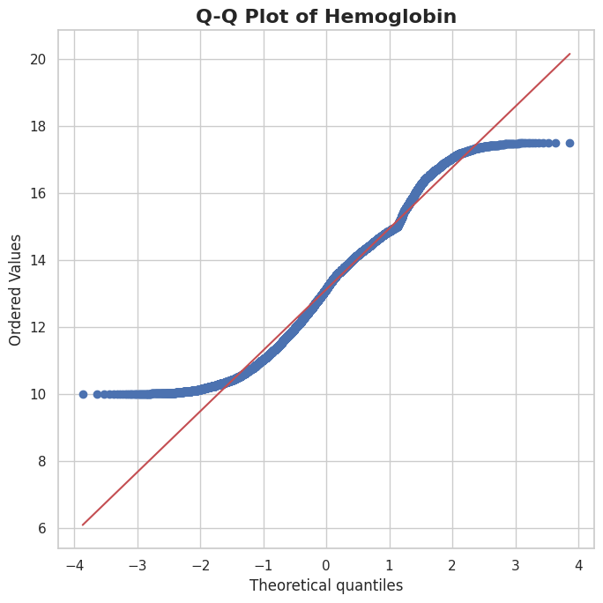

Figure 6. Q-Q plot
Variable | Skewness
Age | 0.016
CRP | 0.162

5.6 Categorical and Binary Distributions
Bar and pie charts were used to summarize Gender, Low-grade fever, Fatigue or chronic tiredness and Joint pain. Binary symptom variables were interpreted using 0 = No and 1 = Yes where specified in the notebook. These plots provide a compact view of the composition of the patient records.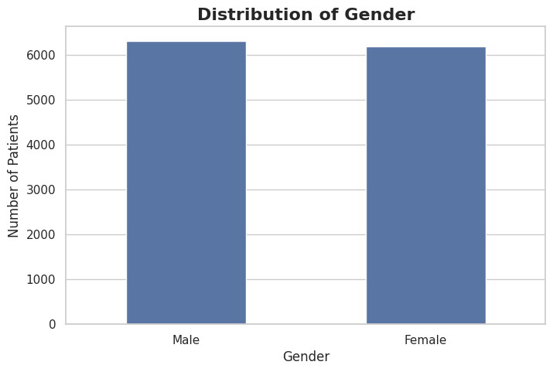
Figure 7A. Gender distribution
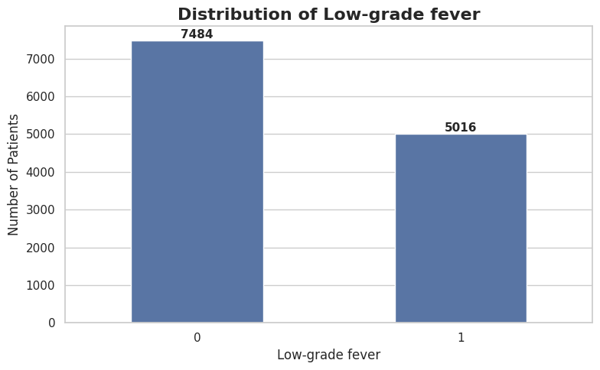
Figure 7B. Low-grade fever distribution
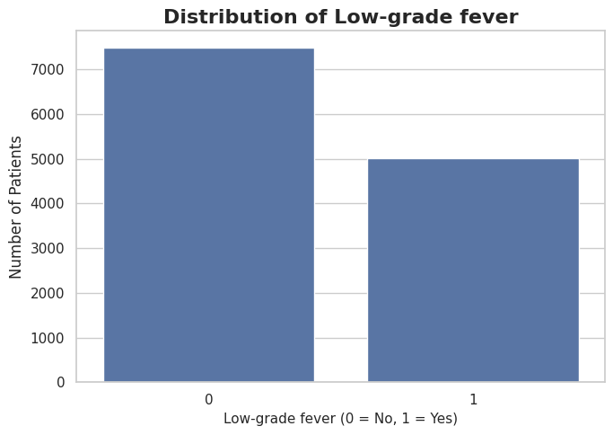
Figure 8A. Low-grade fever binary distribution
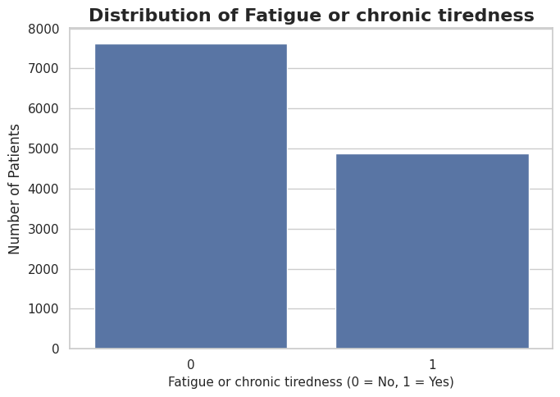

6. BIVARIATE ANALYSIS
Bivariate analysis examines two variables together to identify differences, associations and possible relationships. The Week 4 bivariate notebook includes numerical-vs-numerical, categorical-vs-numerical and categorical-vs-categorical comparisons.

6.1 Age Distribution by Diagnosis
Box plots were created for Age across diagnosis categories. Because the dataset contains many diagnosis categories, the visualization is split into two parts. The notebook also focuses on the top 10 diagnoses by frequency to make group comparisons easier to inspect.
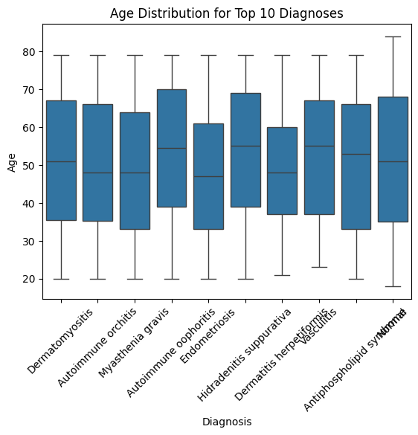

6.2 Neutrophils by Diagnosis
The distribution of Neutrophils was compared across the top 8 diagnoses using box plots. This visualization helps identify differences in central tendency and variability between diagnosis groups.
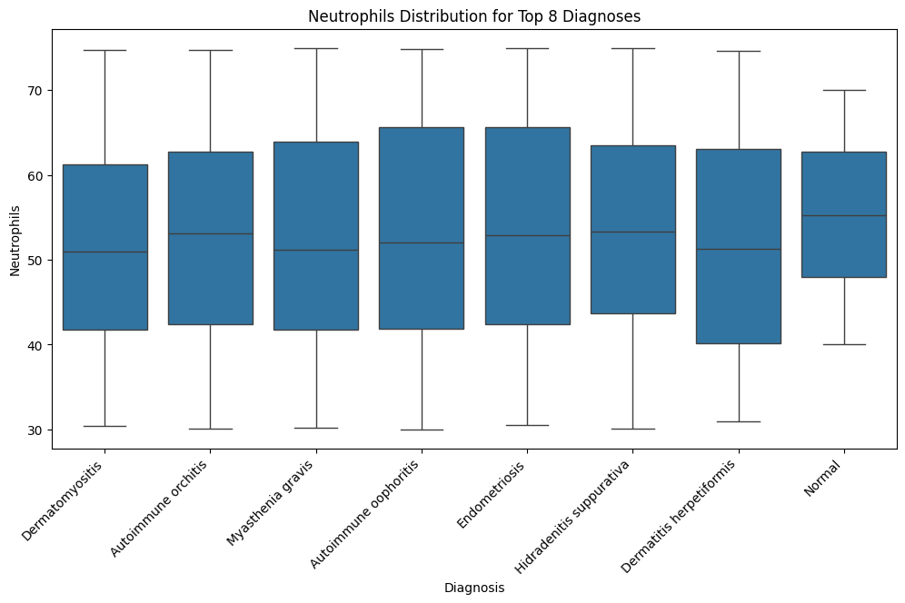
Figure 10. Neutrophils distribution for the top 8 diagnoses

6.3 WBC Count vs CRP
A hexbin plot was used to examine WBC_Count and CRP. Hexbinning is useful when many observations overlap because it groups nearby points into cells and represents the number of observations in each region.
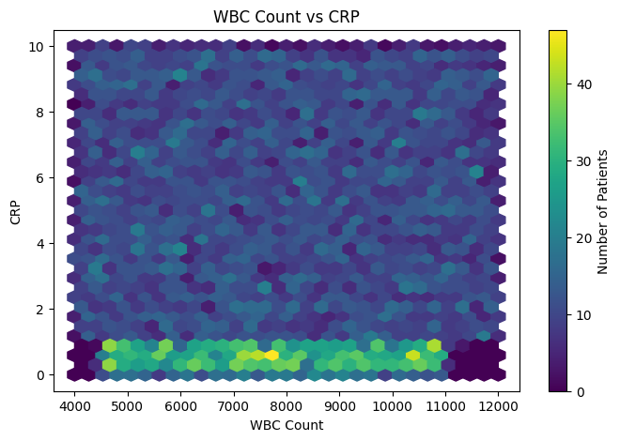
Figure 11. WBC Count versus CRP using a hexbin plot

6.4 Gender and ANA Status
A cross-tabulation of Gender and ANA was visualized with a bar chart. This provides a direct comparison of ANA status counts within the gender categories.
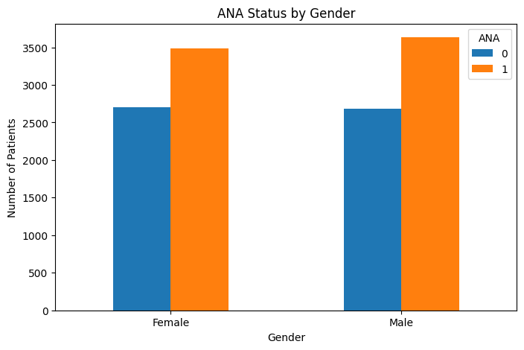
Figure 12. ANA status by gender

6.5 Gender Distribution across Top Diagnoses
For the ten most frequent diagnoses, Gender was cross-tabulated and displayed as a stacked bar chart. The visualization shows how the gender composition varies across these diagnosis groups.
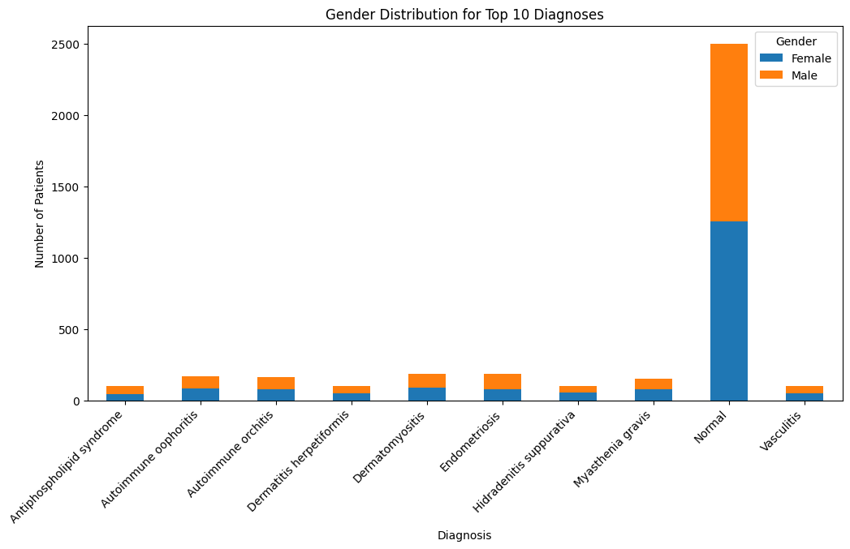
Figure 13. Gender distribution for the top 10 diagnoses

6.6 CRP by Anti-dsDNA Status
A box plot compares CRP distributions across Anti-dsDNA status categories. This allows the spread and central tendency of CRP to be inspected separately for the antibody-status groups.
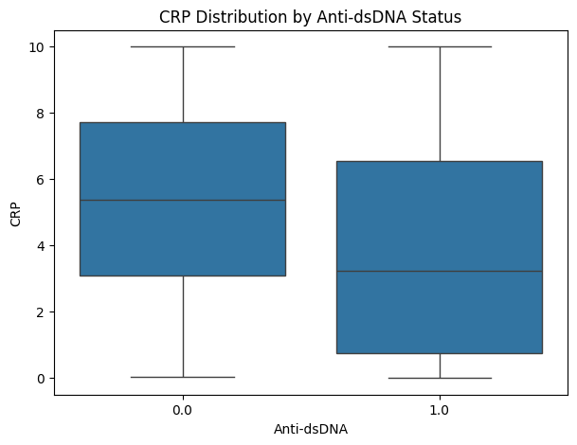
6.7 Fatigue by Gender and Hemoglobin by Gender
The notebook compares Fatigue / chronic tiredness counts across Gender and also compares Hemoglobin distributions by Gender. These plots demonstrate how categorical grouping can be combined with either counts or numerical distributions.
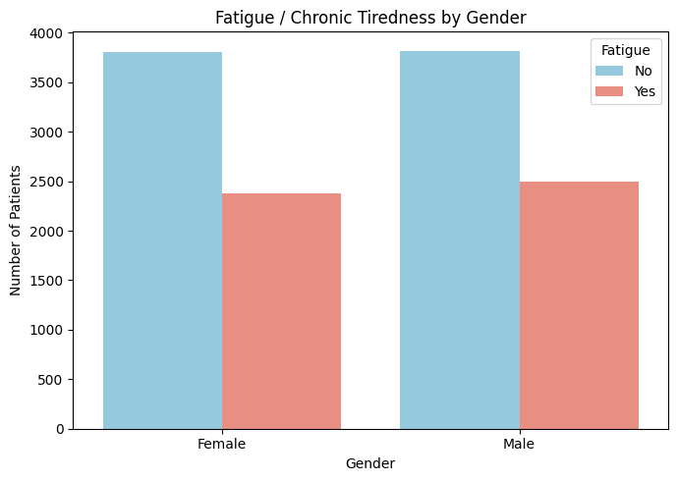
Figure 15. Fatigue / chronic tiredness by gender
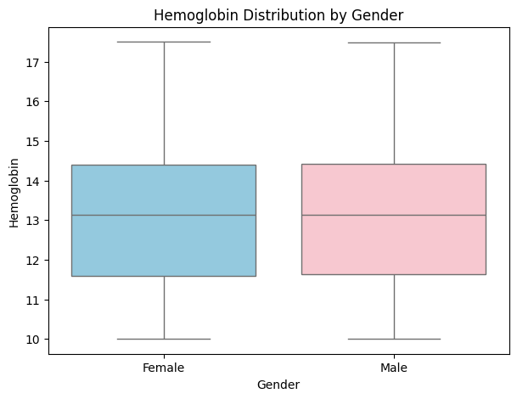
Figure 16. Hemoglobin distribution by gender

6.8 Joint Pain by Gender
The notebook calculates the mean of the binary Joint pain variable within each Gender group and converts it to a percentage. This gives the percentage of records marked as having joint pain for each gender category.
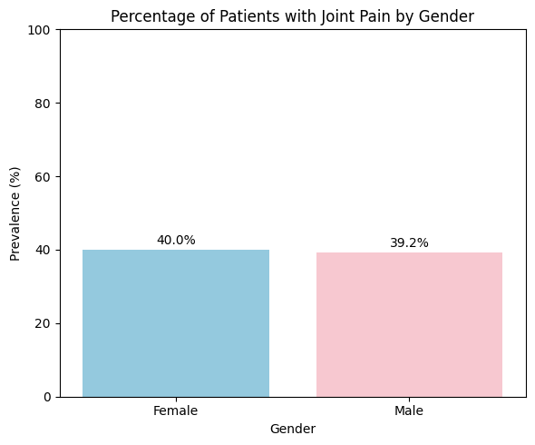
Figure 17. Percentage of patients with joint pain by gender

6.9 Joint Pain and Joint Stiffness by Gender
Joint pain and stiffness are compared using grouped bars after aggregating the binary symptom indicators by Gender. The plot supports a direct comparison of the number of records associated with the two symptoms.
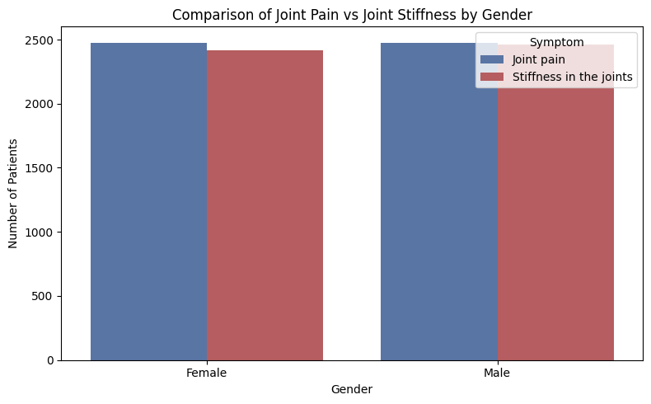
Figure 18. Joint pain versus joint stiffness by gender

7. ADDITIONAL RELATIONSHIP ANALYSIS
The bivariate notebook also contains broader relationship visualizations. These extend the basic pairwise analysis and help examine how several related measurements behave together.

7.1 Correlation Matrix
A correlation heatmap was created for Age, RBC_Count, Hemoglobin, Hematocrit, WBC_Count, PLT_Count, CRP and ESR. The matrix provides pairwise correlation coefficients and can be used to identify measurements that move together or show relatively weak linear association.
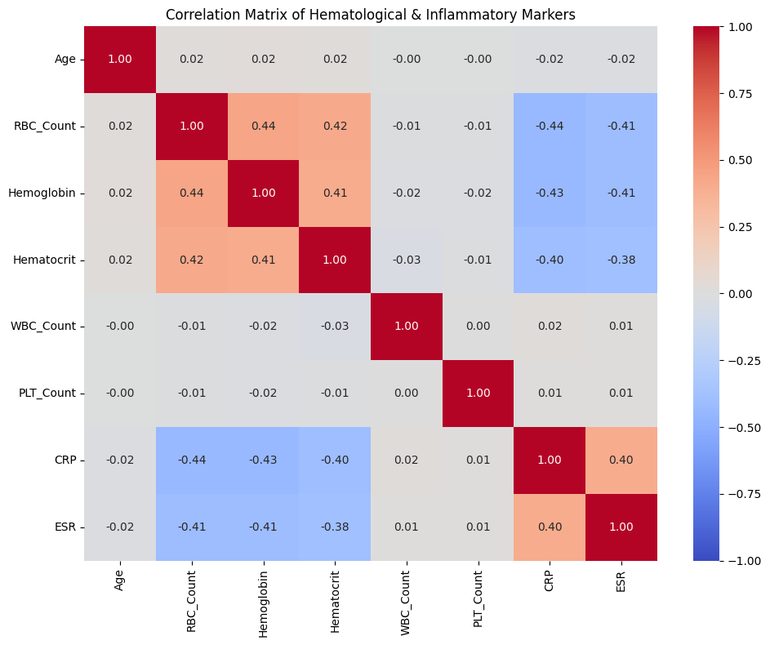

7.2 Autoantibody Positivity Across Top Diagnoses
For the five most frequent diagnoses, the notebook calculates the mean of selected binary autoantibody variables and expresses the result as a percentage. The resulting heatmap summarizes positivity rates for ANA, Anti-dsDNA, Anti-Sm, Rheumatoid factor, ACPA, Anti-TPO and ANCA.
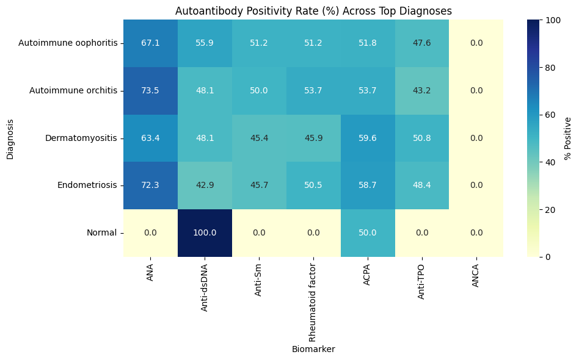
Figure 20. Autoantibody positivity rates across the top diagnoses

7.3 Pairwise CBC Relationships
A pairplot was used for Hemoglobin, Hematocrit, RBC_Count and WBC_Count, with Gender used as the grouping variable. The diagonal shows individual distributions while the off-diagonal panels show pairwise relationships.
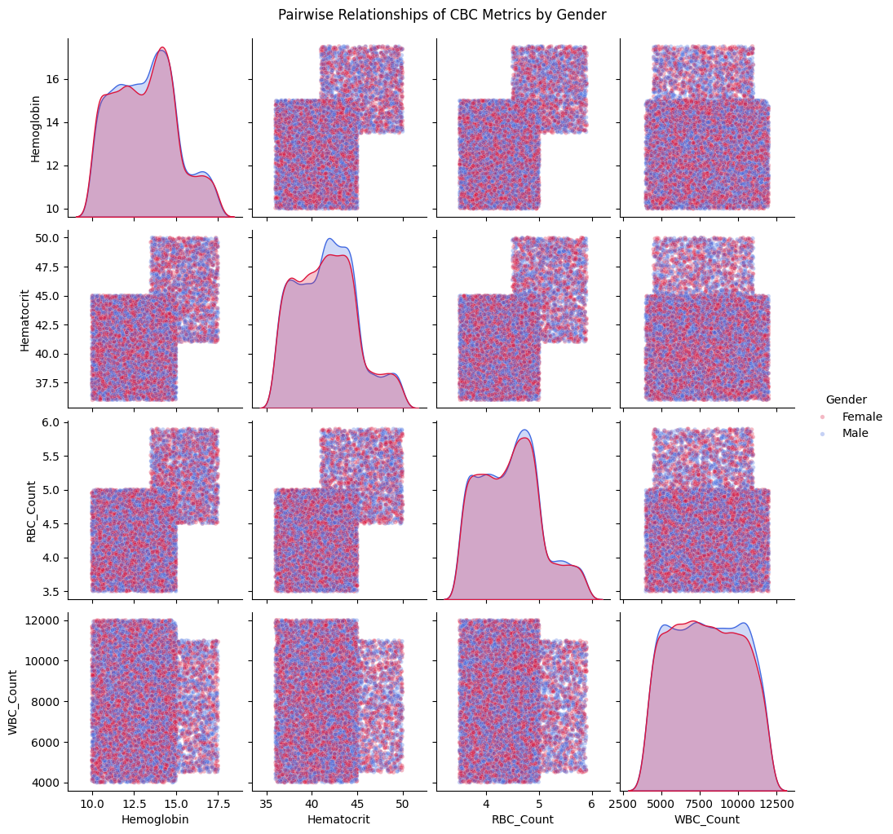
Figure 21. Pairwise relationships of CBC metrics by gender

7.4 Three-Dimensional Relationship
A 3D scatterplot represents Age, WBC_Count and CRP simultaneously. Joint pain is used to distinguish the points through the binary 0/1 indicator. This visualization gives a combined view of demographic, hematological and inflammatory measurements.
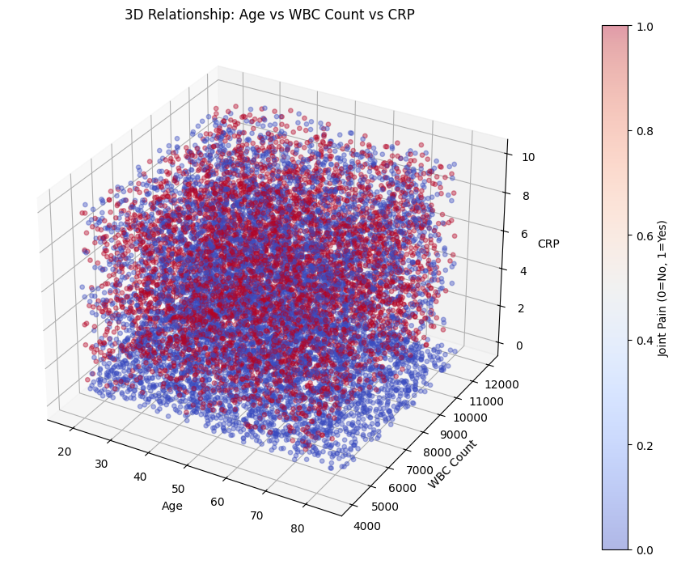
Figure 22. 3D relationship among Age, WBC Count and CRP

8. KEY OBSERVATIONS
• Age and Hemoglobin were examined using histograms with KDE curves, providing a direct view of their distributions.
• Box plots, violin plots and ECDF plots were used to examine spread and distribution shape for laboratory variables.
• The reported skewness values for Age (0.016) and CRP (0.162) are both close to zero, indicating limited positive skew in these selected variables.
• Categorical and binary variables were summarized with bar charts and pie charts, making group composition easier to inspect.
• Age and Neutrophil distributions were compared across diagnosis groups using box plots.
• Gender was compared with ANA status, fatigue, hemoglobin and joint-pain prevalence using several complementary visualizations.
• WBC_Count and CRP were examined together with a hexbin plot, while the broader numerical relationship structure was summarized with a correlation heatmap.
• The analysis also examined autoantibody positivity rates across frequently occurring diagnosis groups.
• The Week 4 work provides visual evidence for patterns and group differences, but exploratory plots alone do not establish causation.

9. WEEK 4 ACTIVITY STATUS

Activity | Status
Univariate numerical analysis | Completed
Numerical distribution visualization | Completed
Categorical / binary distribution visualization | Completed
Skewness and Q-Q analysis | Completed
Bivariate numerical comparisons | Completed
Categorical and numerical comparisons | Completed
Diagnosis-wise comparisons | Completed
Correlation and relationship visualizations | Completed
Preparation for further EDA | Completed

10. CONCLUSION
Week 4 successfully completed the EDA Deep Dive for Team 12. Univariate analysis was used to understand the distribution and shape of important clinical variables, while bivariate analysis examined relationships and differences between demographic, diagnostic, symptom, hematological and inflammatory variables. A wide range of visualizations—including histograms, box plots, violin plots, ECDFs, Q-Q plots, bar charts, pie charts, hexbin plots and correlation heatmaps—was applied according to the type of variable being studied.
The analysis builds directly on the cleaned dataset prepared in Week 3 and provides a visual foundation for deeper statistical analysis and interpretation in later stages of the project.

11. PROJECT STATUS
WEEK 4 – EDA DEEP DIVE: COMPLETED
Univariate analysis completed • Distributions visualized • Bivariate comparisons completed • Relationship analysis completed • Correlation visualization completed

12. GITHUB REPOSITORY
Team 12 repository: https://github.com/nivetha486/24ADI204_DSV_Team12

13. TEAM 12
Nivetha S — 25BAD074
Pooja T — 25BAD077
Puvi Priya M — 25BAD084
Vaishnavi D — 25BAD126

